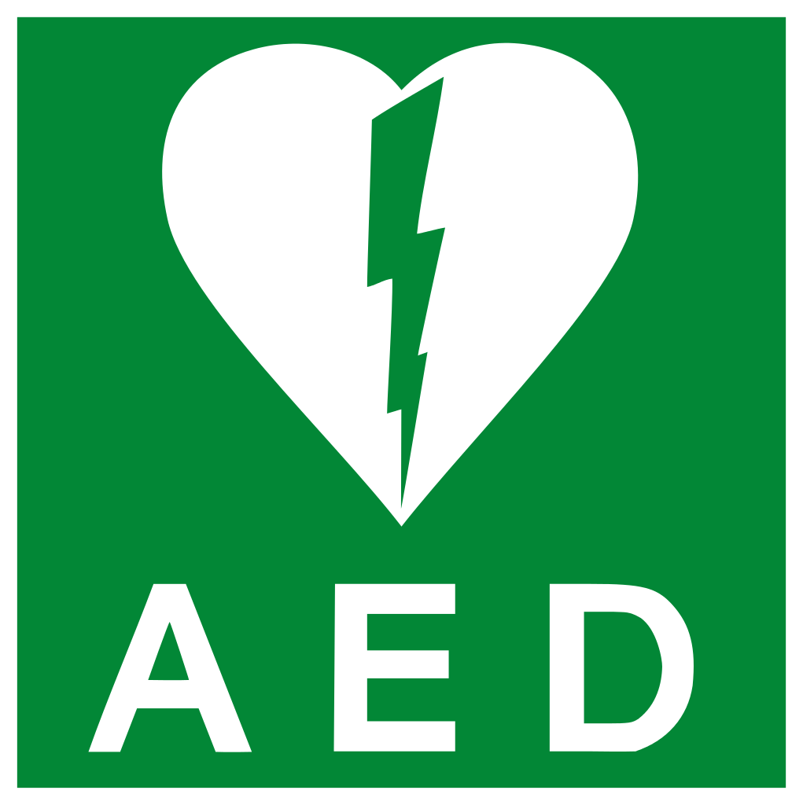
YOU ARE INVITED TO A PUBLIC TRAINING COURSE

CPR and Defibrillator Training Course
Tuesday 31st March
7.00pm
Lostock Gralam Community Centre

Cost: voluntary donation to North West Ambulance Service

Come along and learn life saving skills and how to use your Lostock Gralam Public Access defibrillator located on the outside wall of Eastfield Pharmacy

