LOSTOCK GRALAM PARISH COUNCIL

Lostockgralam.pc@outlook.com

Clerk: Mrs L Sandison
14 Mereworth Drive
Kingsmead
Northwich
Cheshire
CW9 8WY

Tel: 07739 926 025

You are hereby summond to attend an Extraordinary meeting of Lostock Gralam Parish Council to be held at The Watermead on Thursday 24th May 2018 due to commence at 7.00pm for the purpose of transacting the following business:

BUSINESS

Part I –

- Apologies for absence.
- Declaration of Interest.
- To discuss topics for the Parish Council Newsletter and to agree the format.
- To agree how the Newsletter will be printed & any associated costs.
- Any other business.

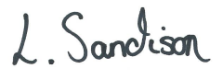

Mrs L Sandison
Clerk to the Council
18/05/2018

